Indices & Index Laws; Exponential Functions; Differential Calculus – Notes

Find an equation of the tangent to the curve y = $\frac{x^{2}-x^{3}}{x^{4}}$ at the point where x = –1.
y = $\frac{1}{x^{2}}$ – $\frac{1}{x}$ → y’ = $–\frac{2}{x^{3}}$ + $\frac{1}{x^{2}}$ → x = –1 → y’ = 3 → y = 3x + c → (–1, 2) → c = 5
y = 3x + 5

Find the coordinates of the point(s) on the curve y = $\frac{1}{x}$ + x with a gradient of 0.
y’ = $–\frac{1}{x^{2}}$ + 1 = 0 → x² = 1 → x = $±$1 → (1, 2), (–1, –2)

The curve y = ax³ + bx² + 4x + 1 has a gradient of 2 at the point (–1, –4). Find a and b.
y’ = 3ax² + 2bx + 4 → 3a – 2b = –2 → –a + b – 4 + 1 = –4 → –a + b = –1
3a – 2b = –2, –3a + 3b = –3 → solve simultaneously → b = –5, a = –4

Given that y = ax³ + bx² + 2 has a tangent with equation y = –4x + 5 at the point where x = 1, find a and b.
y’ = 3ax² + 2bx → x = 1 → 3a + 2b = –4 → (1, 1) → a + b = –1
3a + 2b = –4, 3a + 3b = –3 → b = 1, a = –2

A curve has equation y = $\frac{x^{3}}{3}$ + $\frac{x^{2}}{2}$ – 4x + 1. The points A and B lie on this curve and the tangents to the curve at A and B are parallel to the line 2x – y = 5. Find the coordinates of the points A and B.
y’ = x² + x – 4 = 2 → y’ = (x+3)(x–2) → x = –3, 2 → (–3, 8.5), (2, $–\frac{7}{3}$)

The tangent to the curve y = x³(x + 2) at the points where x = 1 and x = –1 met at the point Q. Find the coordinates of the point Q.
y = x⁴ + 2x³ → y’ = 4x³ + 6x² → x = 1 → y’ = 10 → y = 10x + c → (1, 3) → c = –7
x = –1 → y’ = 2 → y = 2x + c → (–1, –1) → c = 1
10x – 7 = 2x + 1 → 8x = 8 → x = 1 → (1, 3)

The curve has equation y = (x – 2)(2x² – 5x + 2). The points A and B lie on this curve. The tangents to the curve at A and B are parallel to the line 12x – y = 5. Find the coordinates of the points A and B.
y = 2x³ – 5x² + 2x – 4x² + 10x – 4 = 2x³ – 9x² + 12x – 4 → y’ = 6x² – 18x + 12 = 12 =
6x(x–3) = 0 → x = 0, 3 → (0, –4), (3, 5)

Use an appropriate derivative to evaluate $\lim_{h→0}{\frac{{\left(1+\sqrt{5+h}\right)}^{2}–(1+\sqrt{5})^{2}}{h}})$ giving your answer in exact form.
$\frac{d}{dx}$(1 + $\sqrt{x}$)² |x=5 → 2(1+$\sqrt{x}$) x $\frac{1}{2\sqrt{x}}$ |x=5 → $\frac{1+\sqrt{x}}{\sqrt{x}}$ |x=5 → $\frac{1}{\sqrt{5}}$ + 1 = $\frac{\sqrt{5}}{5}$ + 1

Simplify each of the following, leaving answers with positive indices.
[a] $\frac{5^{n+1}–5^{n}}{8}$
$\frac{5^{n}(5–1)}{8}$ = $\frac{(4)5^{n}}{8}$ = $\frac{5^{n}}{2}$

[b] $\frac{5^{n+2}–5^{n+1}}{2(5^{n+1})}$
$\frac{5^{n+1}(5–1)}{2(5^{n+1})}$ = $\frac{(4)5^{n+1}}{2(5^{n+1})}$ = 2

[c] $\frac{7^{n–1}+7^{n}}{4 x 7^{n–1}}$
$\frac{7^{n–1}(1+7)}{(4)7^{n–1}}$ = $\frac{(8)7^{n–1}}{(4)7^{n–1}}$ = 2

[d] $\frac{3^{2n}+3^{n}}{3^{n+1}+3}$
$\frac{3^{n}(3^{n}+1)}{3(3^{n}+1)}$ = $\frac{3^{n}}{3}$ = 3^{n–1}

[e] $\frac{2^{n+1}+8}{3(2^{n})+12}$
$\frac{2(2^{n}+4)}{3(2^{n}+4)}$ = $\frac{2}{3}$

Solve for t.
[a] 3^{2t+1} = 81
2t + 1 = 4 → t = $\frac{3}{2}$

[b] 4^{1-t} = 32
2(1–t) = 5 → 2 – 2t = 5 → t = $–\frac{3}{2}$

[c] 5^{2+t} = $\frac{1}{125}$
2 + t = –3 → t = –5

[d] 5^{t} x 25^{t–1} = 0.04
t + 2t – 2 = –2 → t = 0
[e] $\frac{2^{2t+1}}{2^{1–t}}$ = 4
2t + 1 – 1 + t = 3t = 2 → t = $\frac{2}{3}$

Solve for x in (2^{x})² + 2(2^{x}) – 8 = 0.
(2^{x} + 4)(2^{x} – 2)
2^{x} = –4, 2 → x = 1

Solve for x, 3^{2x+1} + 8(3^{x}) – 3 = 0.
3(3^{x})² + 8(3^{x}) – 3
3y² + 8y – 3 = 3y² + 9y – y – 3 = 3y(y+3) – (y+3) = (y+3)(3y – 1)
3^{x} = –3, $\frac{1}{3}$ → x = –1

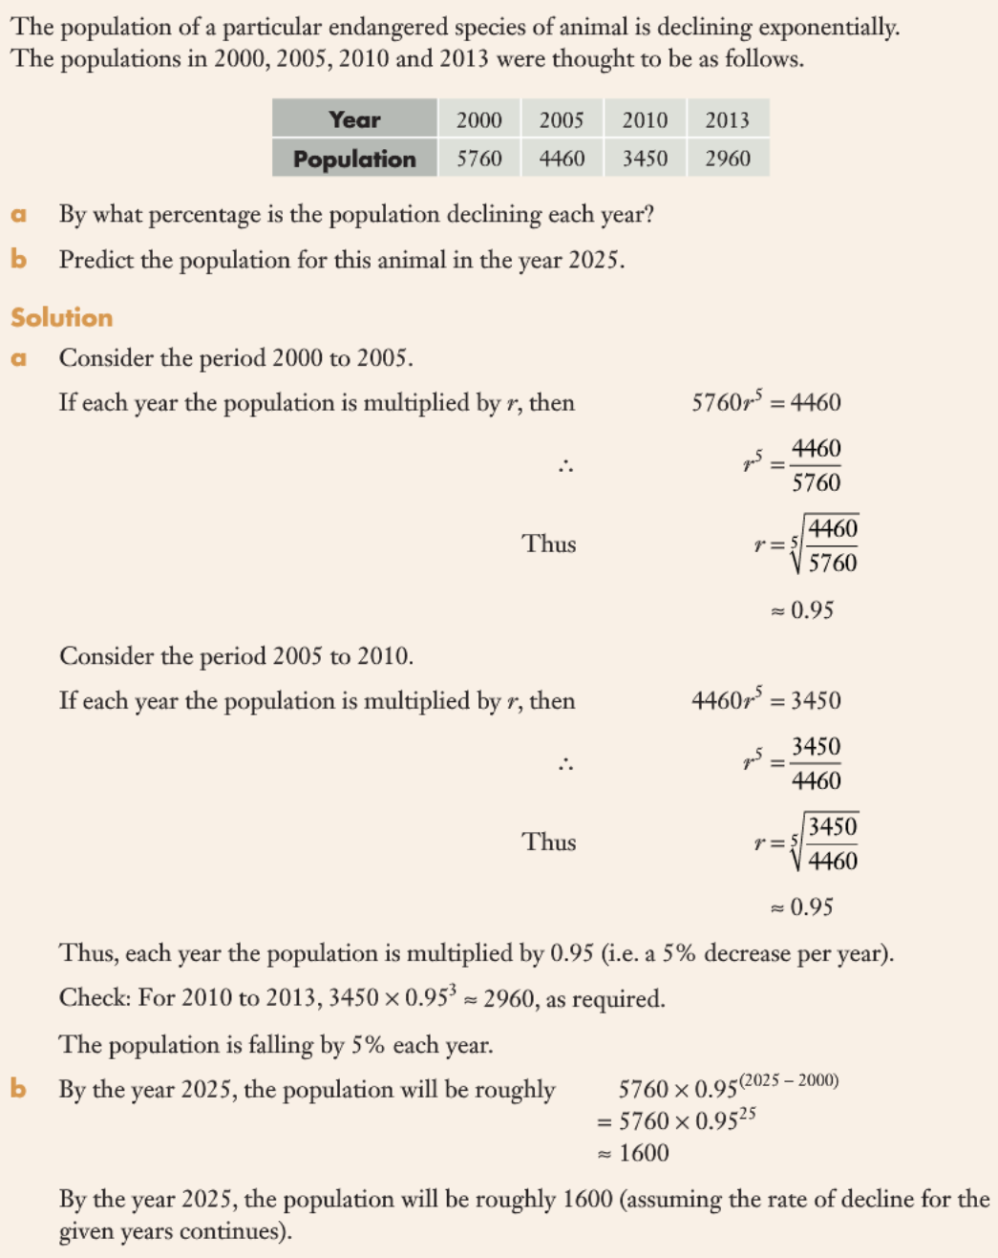
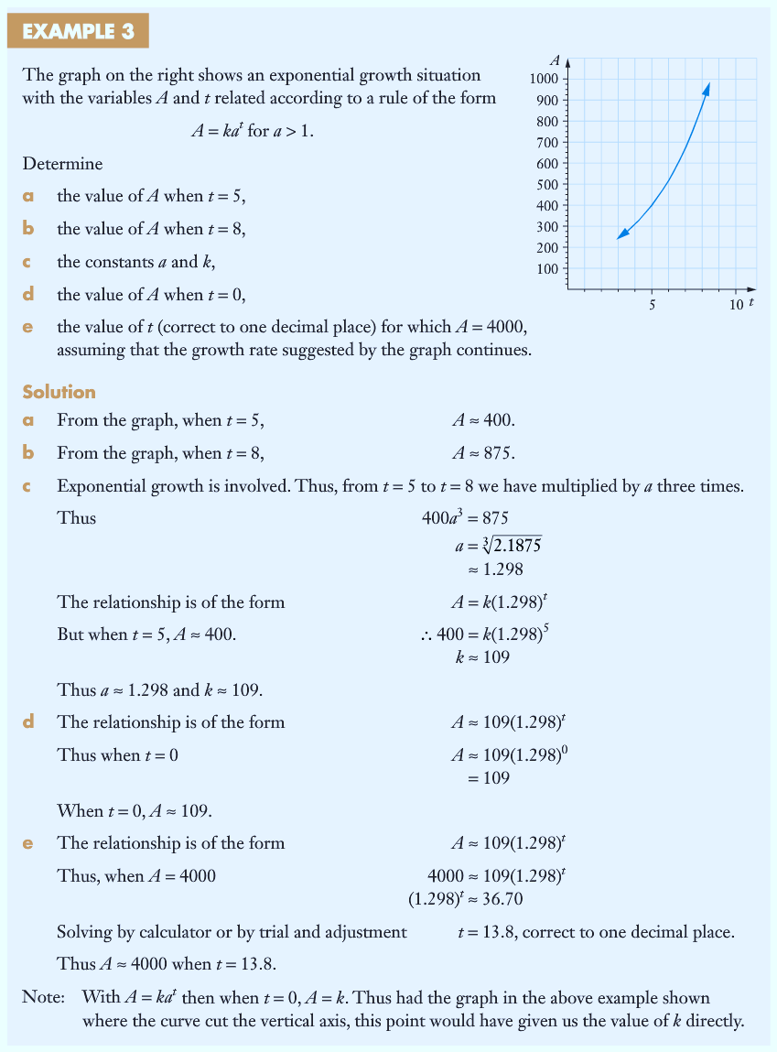
Comment on the difference between your answers in part [b] and [d].
Answer in [d] is the rate of change at that instant in time.
Answer in [b] refers to the average rate of change within an interval of time.

